Appendix: Chapter 4

Intra-aquifer phosphate and arsenic (im)mobilization dynamics during aquifer storage transfer and recovery of tile drainage water

Emiel Kruisdijk*,a,b, Pieter J. Stuyfzanda,c,Boris M. van Breukelena

aDelft University of Technology, Faculty of Civil Engineering and Geosciences, Department of Water Management, Stevinweg 1, 2628 CN Delft, the Netherlands

bAcacia Water B.V., Van Hogendorpplein 4, 2805 BM Gouda, the Netherlands

c Stuyfzand Hydroconsult+, 2042BL Zandvoort, the Netherlands

* Corresponding author: [e.kruisdijk@tudelft.nl](mailto:e.kruisdijk@tudelft.nl)

March 15, 2022

Pages: 18

Figures: 20

Tables: 3

Contents

S1. More information about monitoring the onset of ASTR operation 3

S1.1 Injected volumes until arrival of the spreading front 3

S1.2 Observed concentrations for cations during first days of ASTR operation 3

S1.3 Observed DOC concentrations during onset of ASTR operation 9

S2. More information about the storage periods 11

S2.1 Deviations in chloride concentrations during the storage periods 11

S2.2 NO3, Fe, PO, and As trends during storage periods 12

S2.3 Redox condition observed during storage periods 13

S2.4 Delta SO4 vs Delta Cl 14

S2.5 Correlation between As and PO4 concentrations during storage periods 15

S2.6 Saturation indices at the onset of storage periods 16

S2.7 Saturation indices magnetite at the onset of storage periods 16

S3. Methanogenesis 17

References 18

# S1. More information about monitoring the onset of ASTR operation

## S1.1 Injected volumes until arrival of the spreading front

Table S1: Injected volumes until arrival of the spreading front at each monitoring well.

|  |  |
| --- | --- |
| **Monitoring wells** | **Injected volume until spreading front arrival (m3)** |
| MW-1 | 718 |
| MW-2 | 618 |
| MW-3 | 414 |
| MW-4 | 220 |
| MW-5 | 742 |
| MW-6 | 846 |

## S1.2 Observed concentrations for cations during first days of ASTR operation

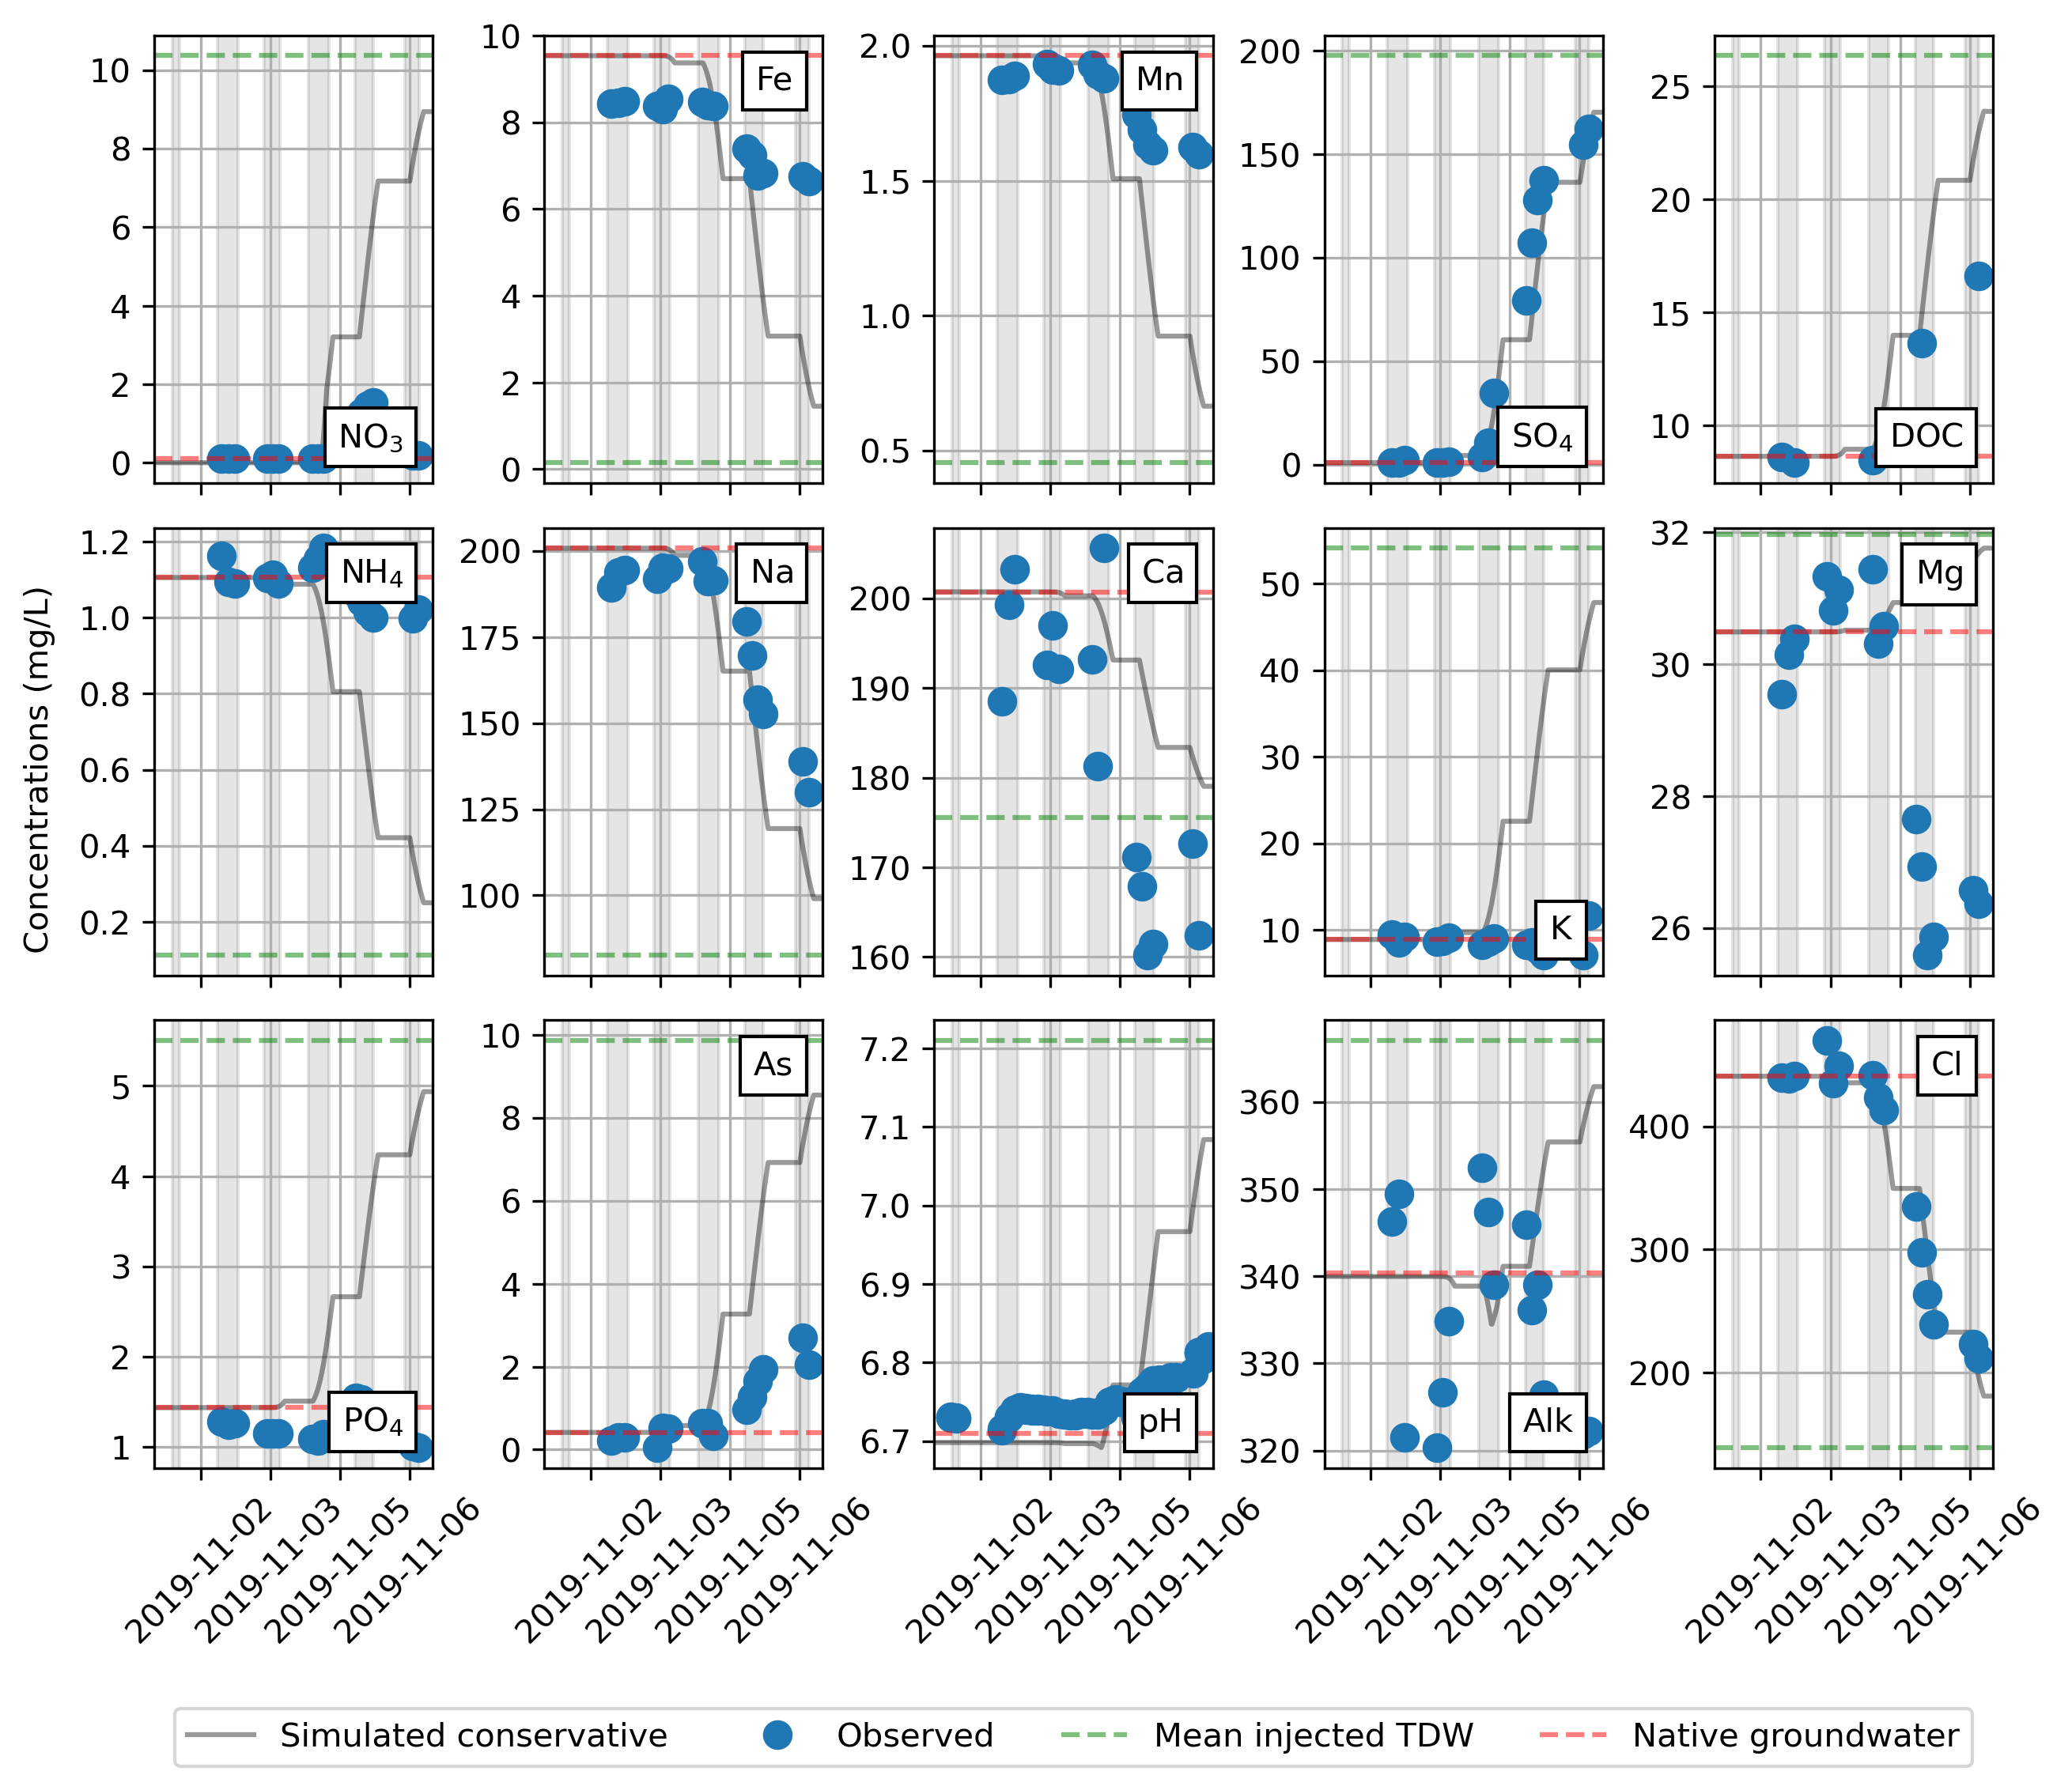

Figure S: Observed and conservative solute concentrations during the arrival of injected TDW at MW1. Concentrations in mg/L except for As (concentrations in ug/L) and pH. Concentrations of mean injected TDW and native groundwater are indicated with horizontal dashed green and red lines, respectively.

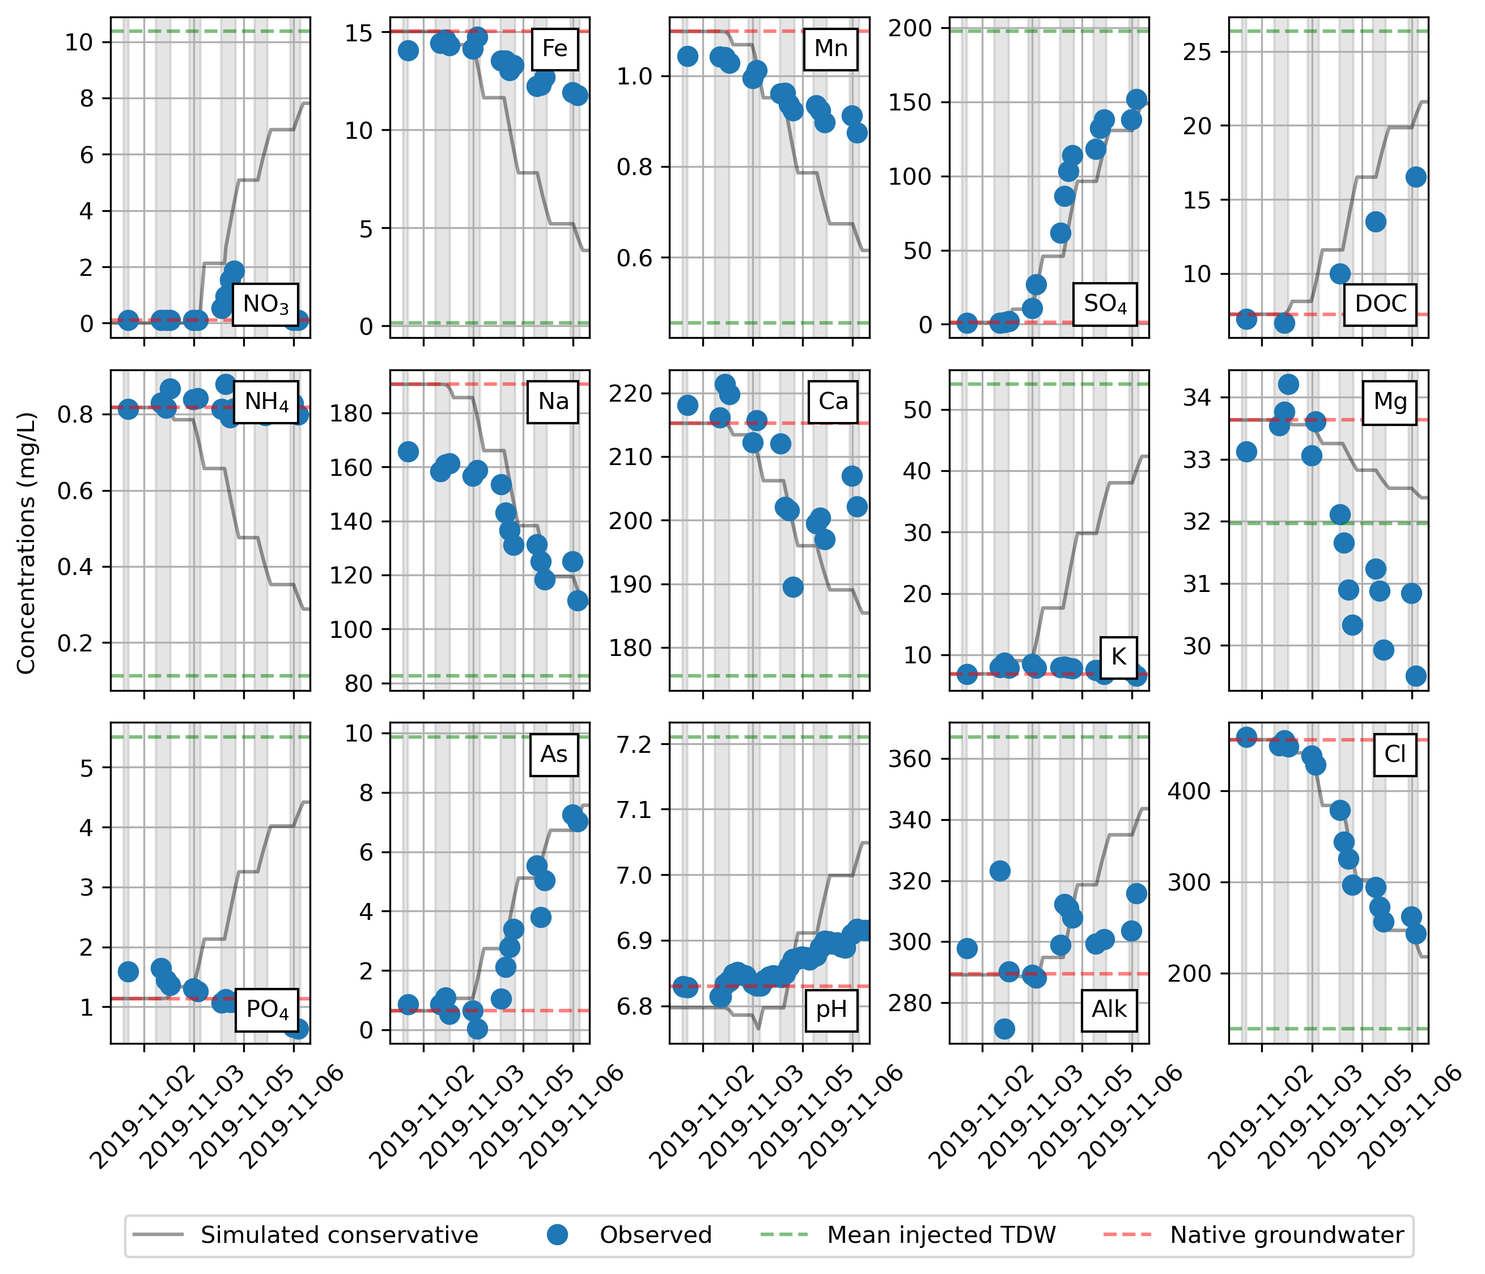

Figure S: Observed and conservative solute concentrations during the arrival of injected TDW at MW2. Concentrations in mg/L except for As (concentrations in ug/L) and pH. Concentrations of mean injected TDW and native groundwater are indicated with horizontal dashed green and red lines, respectively.

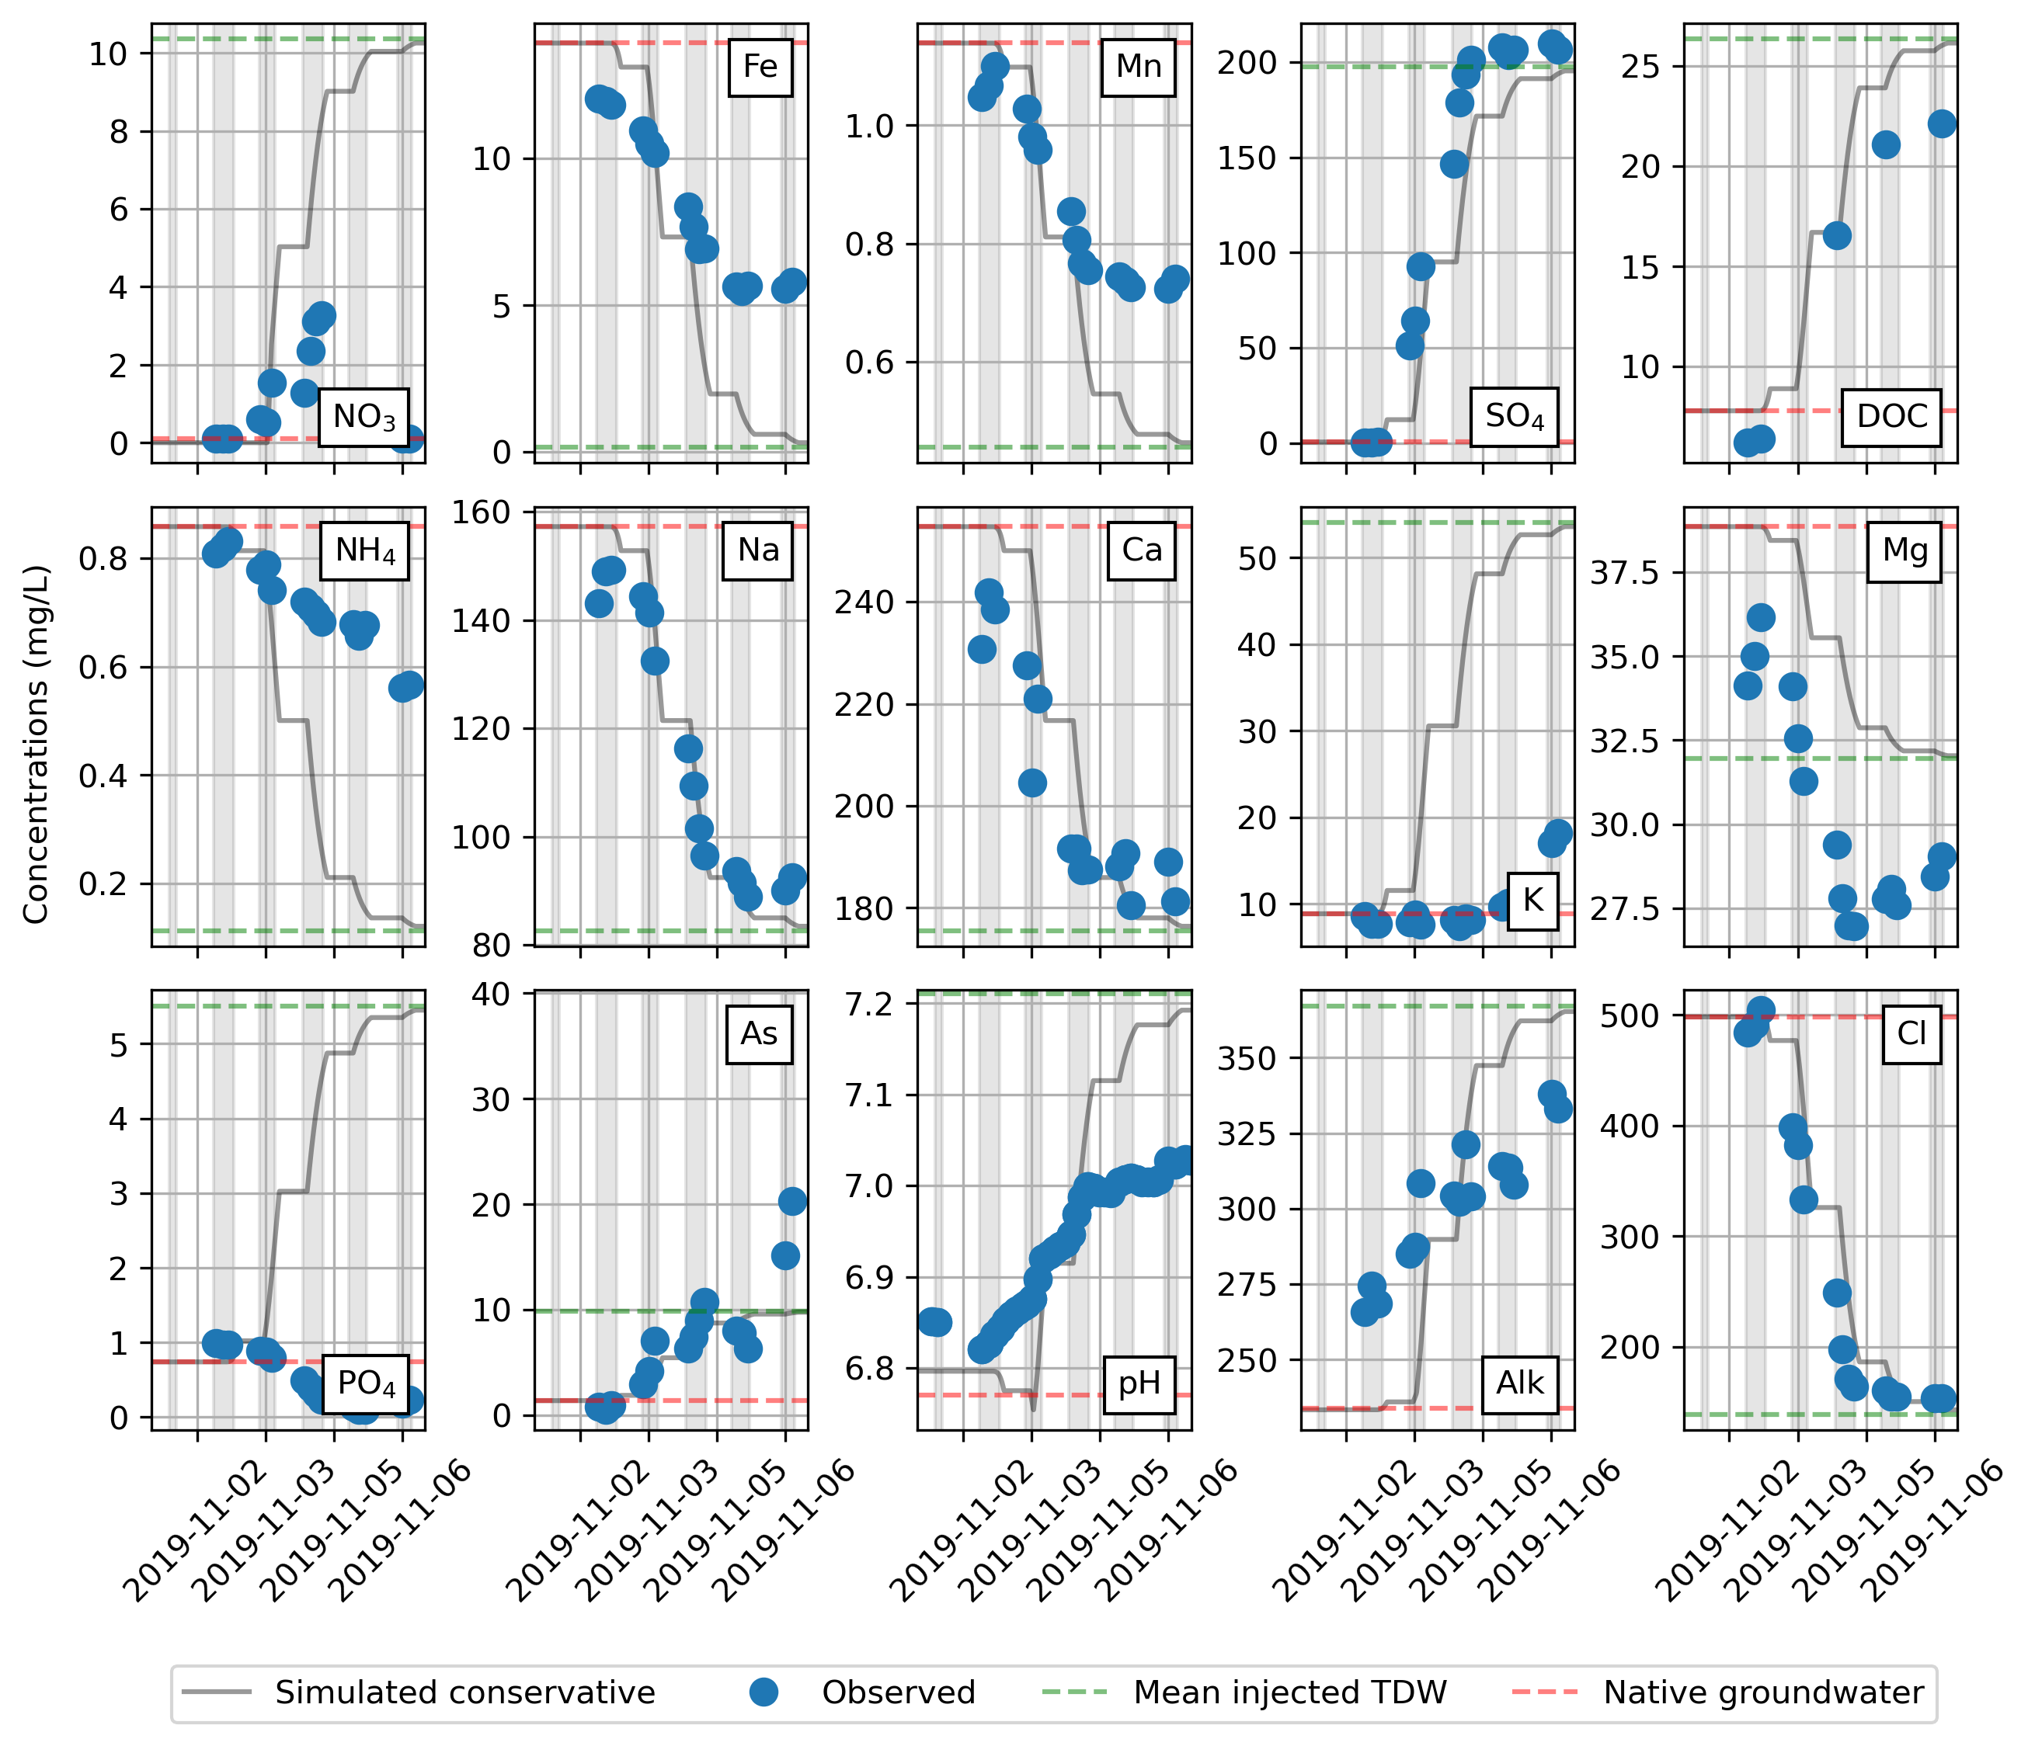

Figure S: Observed and conservative solute concentrations during the arrival of injected TDW at MW3. Concentrations in mg/L except for As (concentrations in ug/L) and pH. Concentrations of mean injected TDW and native groundwater are indicated with horizontal dashed green and red lines, respectively.

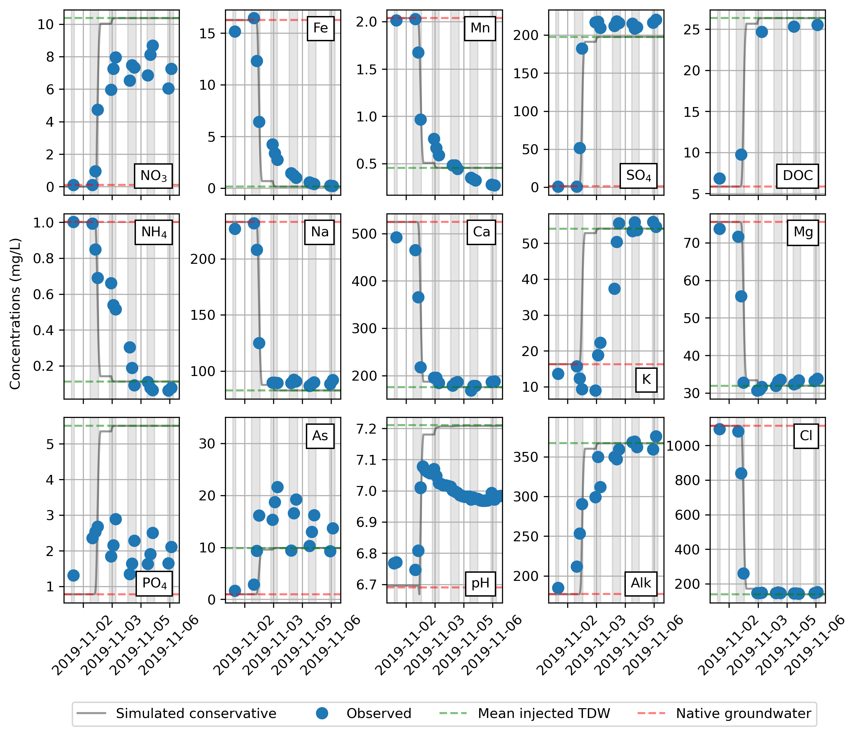

Figure S: Observed and conservative solute concentrations during the arrival of injected TDW at MW4. Concentrations in mg/L except for As (concentrations in ug/L) and pH. Concentrations of mean injected TDW and native groundwater are indicated with horizontal dashed green and red lines, respectively.

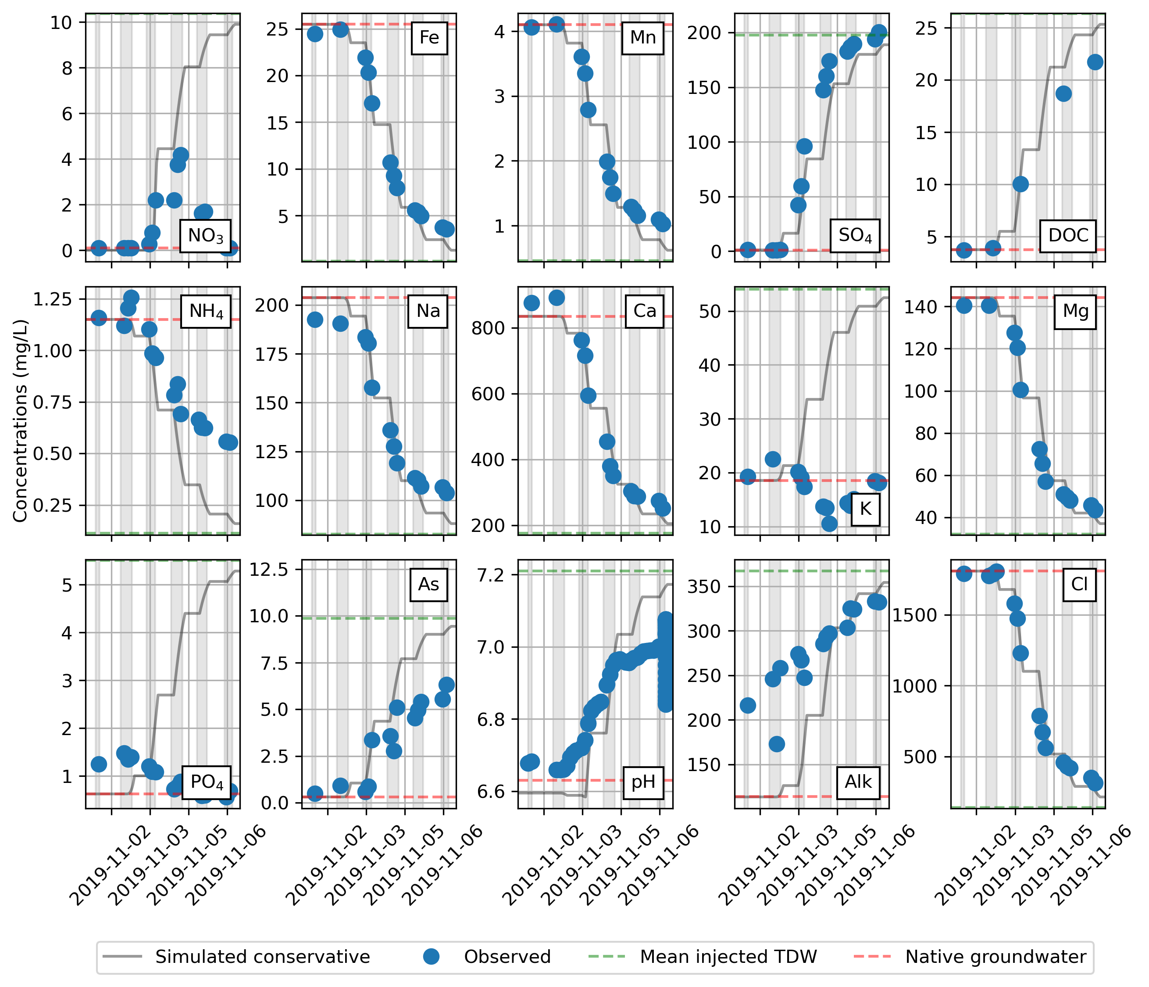

Figure S: Observed and conservative solute concentrations during the arrival of injected TDW at MW5. Concentrations in mg/L except for As (concentrations in ug/L) and pH. Concentrations of mean injected TDW and native groundwater are indicated with horizontal dashed green and red lines, respectively. As concentrations are more unreliable at concentrations <2.5μg/L, due to analytical uncertainty.

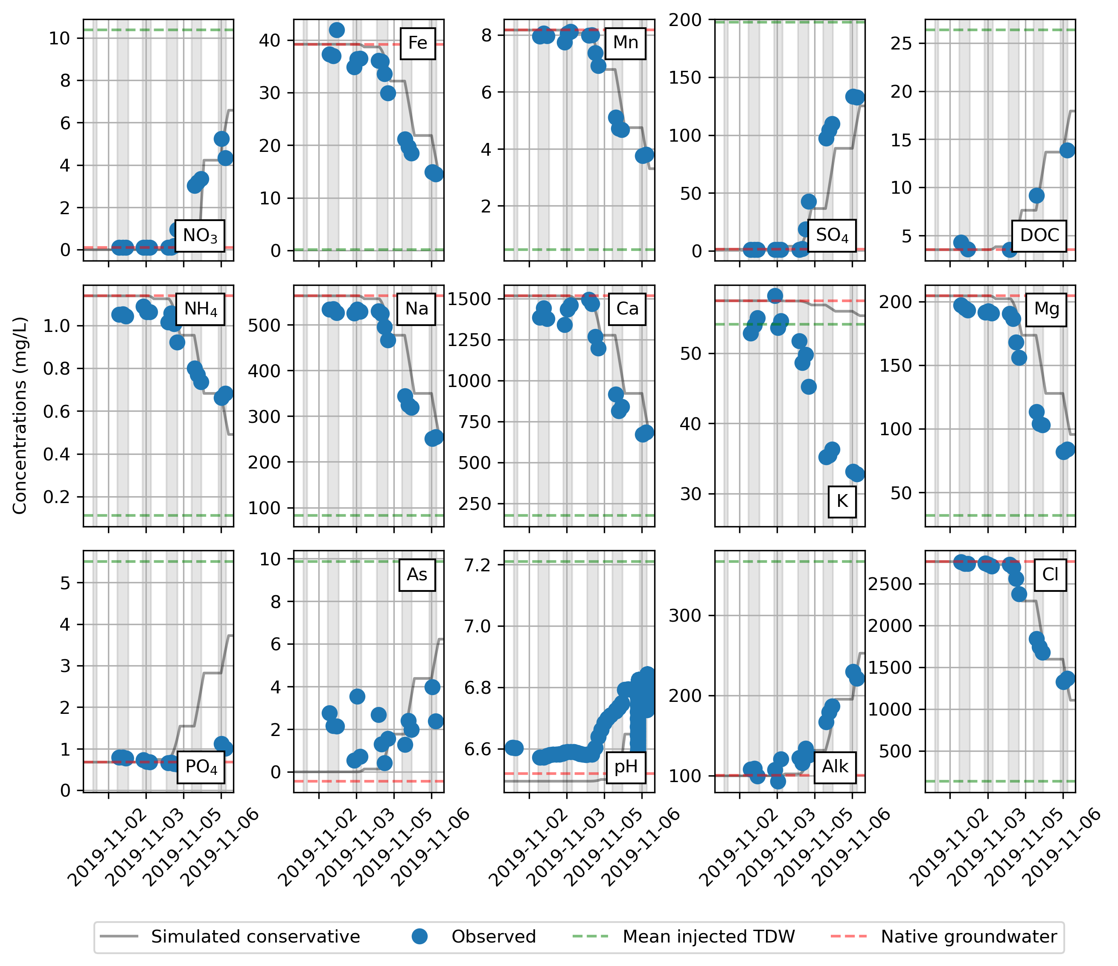

Figure S: Observed and conservative solute concentrations during the arrival of injected TDW at MW6. Concentrations in mg/L except for As (concentrations in ug/L) and pH. Concentrations of mean injected TDW and native groundwater are indicated with horizontal dashed green and red lines, respectively. As concentrations are more unreliable at concentrations <5μg/L, due to analytical uncertainty.

## S1.3 Observed DOC concentrations during onset of ASTR operation

DOC sorption and/or degradation is suggested by the lower observed concentrations compared to the conservative concentrations at all depths during and after the breakthrough (Figure S7). It is hard to visually disentangle DOC sorption and degradation. Therefore, we simulated both separately and assessed their fits to the observed data.

We simulated DOC sorption using the approximate 1D solution for dispersion in radially diverging flow, which was also used for pesticide sorption (Eq. 7-163 in Bear (2012)):

|  |  |
| --- | --- |
| $C\left(r,t\right)=C_{i}+\left(\frac{C_{0}-C_{i}}{2}\right)*erfc\left(\frac{r-r_{50}}{\sqrt{\frac{4}{3}{}_{L}r_{50}}}\right)$, with $r_{50}=\sqrt{\frac{Q(\frac{t}{R})K_{n}}{n_{N}πKD}}$ | (1) |

where $C\left(r,t\right)$ are the observed Cl concentrations (M L-3) at MW1-6 observed at distance $r$ (2.5 m) at time t after the start of injection, $C_{i}$ the DOC concentration of the initial groundwater (M L-3), the mean concentration of the injected TDW (M L-3), the calculated 50% front position of the injected water at time t (L), ${}_{L}$ the longitudinal dispersivity (L), Q is the mean injection rate (L3 T-1), the horizontal hydraulic conductivity of layer N (L T-1), the porosity of layer N (-), and KD the transmissivity of the target aquifer (L2 T-1).

Unfortunately, DOC degradation could not be simulated using this analytical equation, instead a variant of the Ogata-Banks equation was used, which includes first-order degradation (Domenico and Schwartz, 1998) with λ = decay constant = 0.694/T½:

|  |  |  |
| --- | --- | --- |
|  | $$C\left(x,t\right)=C_{i}+\left(\frac{C_{0}-C_{i}}{2}\right)*\exp\left(\left(\frac{x}{2α_{L}}\right)\left(1-\sqrt{\left(1+\frac{4λα_{L}}{v}\right)}\right)\right)*erfc\left(\frac{x-vt\sqrt{\left(1+\frac{4λα_{L}}{v}\right)}}{\sqrt{(4α_{L}t})}\right)$$ | (2) |

This equation assumes linear instead of radial flow, therefore we first assessed the introduced error by using this equation. Longitudinal dispersivities were estimated based on both equation 1 and equation 2. Figure S7 shows the simulations of conservative transport using equation 1 and 2. The differences between both simulations are relatively small, which makes the use of equation 2 acceptable. Furthermore, equation 1 was used to estimate the best fit to the observed DOC concentrations by fitting the retardation factor. A better fit to the observed concentrations was obtained compared to conservative transport, although simulated concentrations underestimated observed concentrations at the start of the breakthrough and overestimated concentrations at the end of the breakthrough. Equation 2 was applied to simulate DOC transport including first-order degradation. A better fit to the observed concentrations was observed, which suggests that degradation and not sorption is the main process controlling DOC concentrations during the field injection experiment.

Figure S8: Observed DOC concentrations at different aquifer depths (green dots), and the best fit for solute transport including either retardation (dashed red line) or degradation (dotted blue line). The corresponding retardation factor (R) or first-order degradation rate constant (λ) are shown in the subplots. The grey lines show the simulated conservative lines based on equation 1 and equation 2. The mean injected concentration is shown with a dashed dark green line, its 10% and 90% percentiles with light green dashed lines.

# S2. More information about the storage periods

## S2.1 Deviations in chloride concentrations during the storage periods

Table : Deviations of Cl concentrations during storage period at the different depths.

|  |  |  |  |
| --- | --- | --- | --- |
|  | Cl deviations (%)  ((maximum Cl concentration/minimum Cl concentration-1)×100) | | |
|  | Winter 2019 | Fall 2020 | Spring 2021 |
| MW1 | 2.05 | 1.44 | 1.36 |
| MW2 | 9.03 | 1.98 | 22.0 |
| MW3 | 9.67 | 1.99 | 3.91 |
| MW4 | 2.23 | 2.11 | 3.46 |
| MW5 | 32.0 | 1.96 | 11.4 |
| MW6 | 265 | 45.9 | 12.0 |

## S2.2 NO3, Fe, PO, and As trends during storage periods

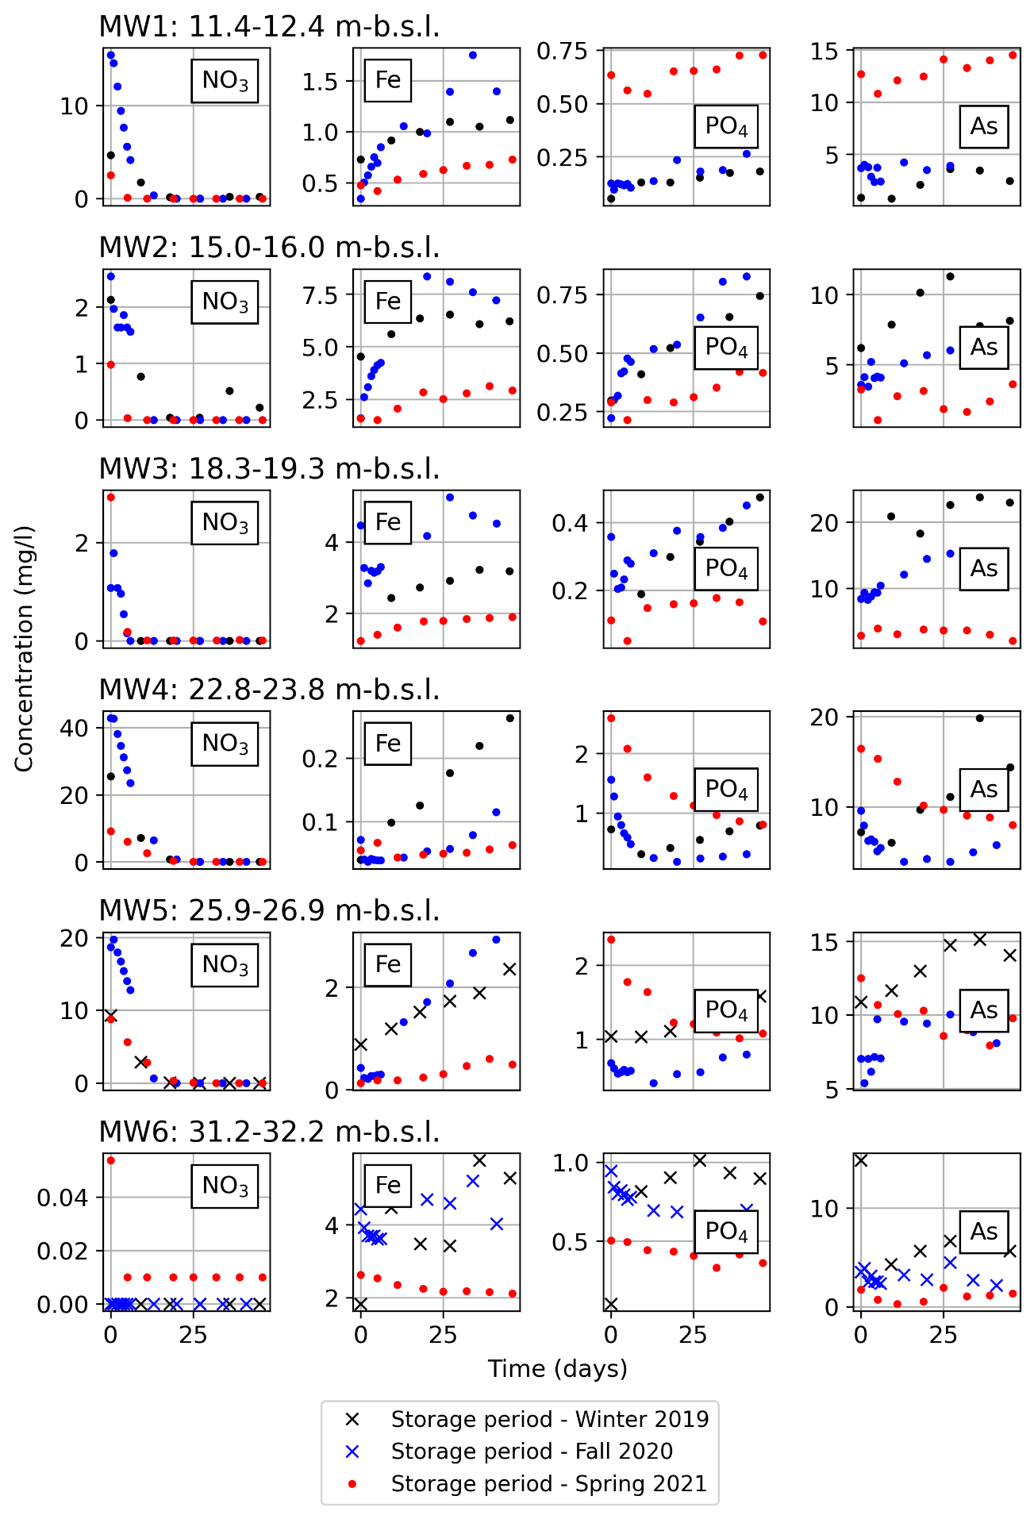

Figure S: Concentration trends of NO3, Fe, PO, and As observed at all depths during the three storage periods. Concentrations of As are in µg/L. The colored dots show the observed concentrations during the storage periods in the winter 2019, fall 2020 and spring 2021. The storage periods where Cl deviations were >25% are depicted with crosses.

## S2.3 Redox condition observed during storage periods

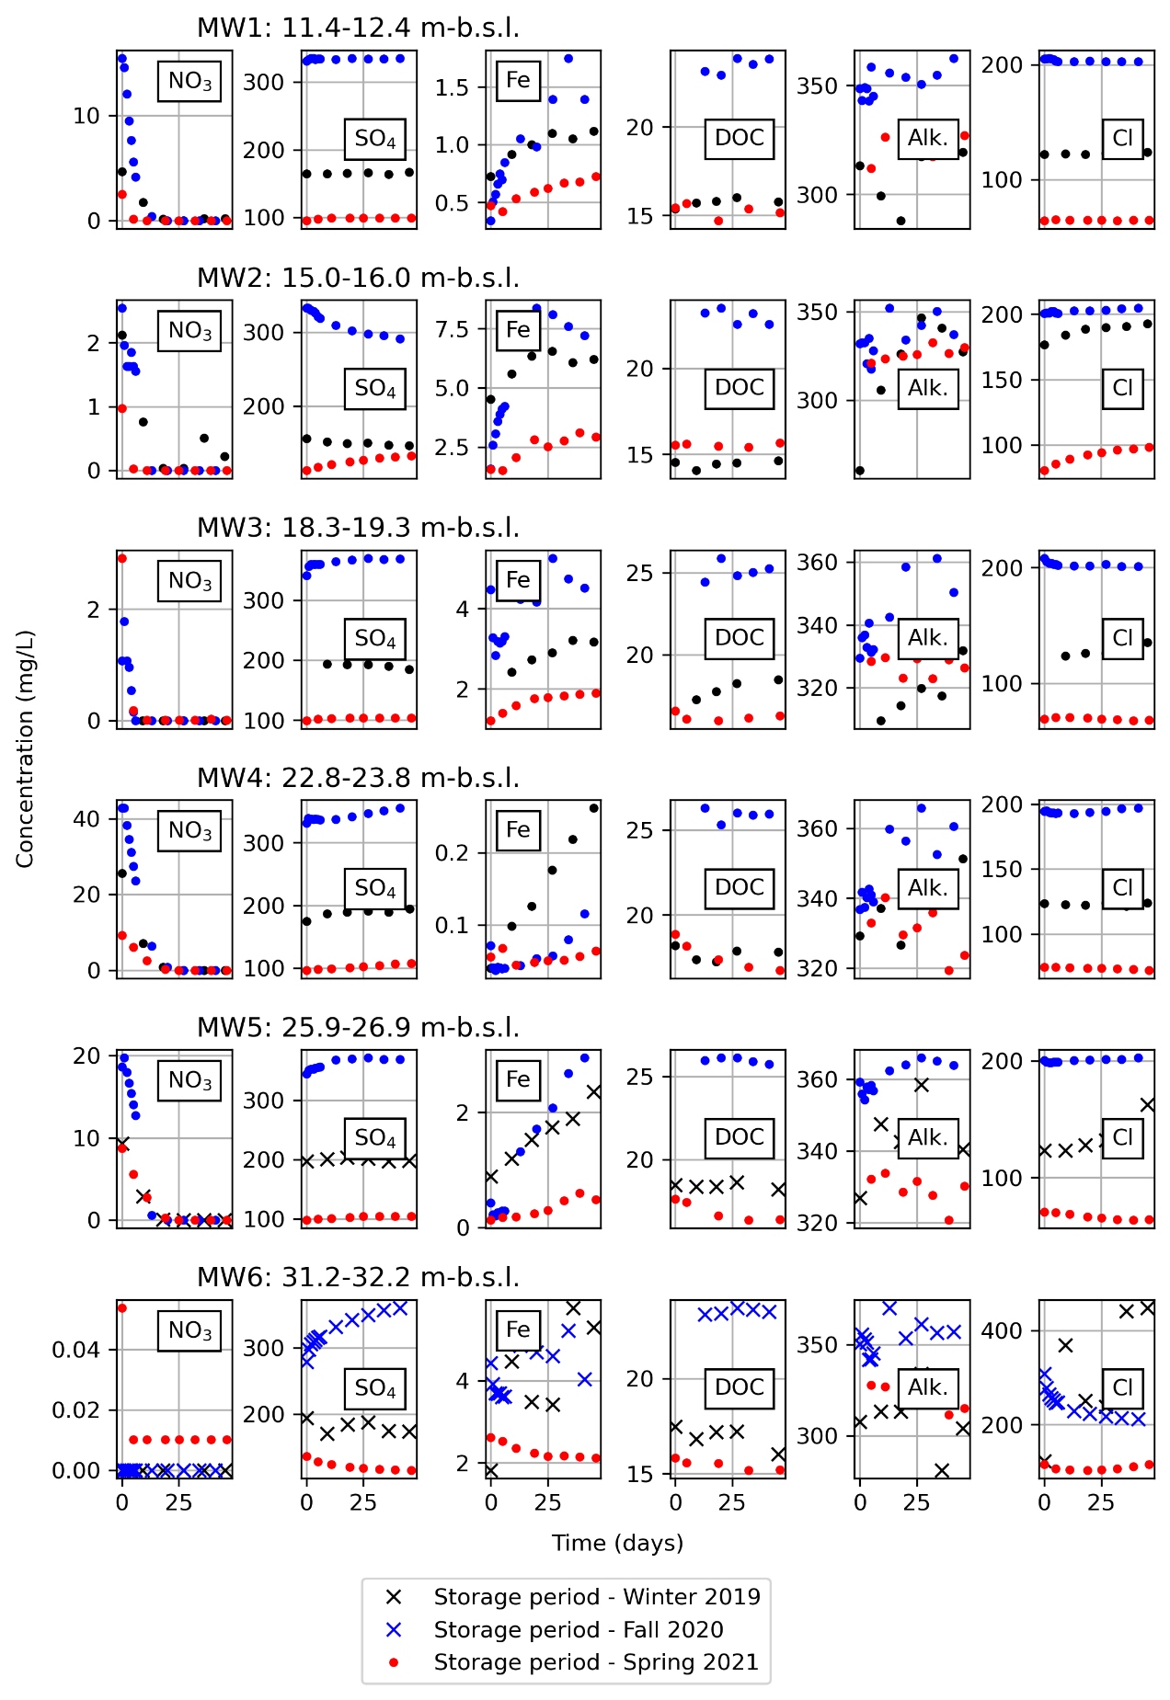

Figure S: Redox conditions observed at all depths during the three storage periods. The colored dots show the observed concentrations during the storage periods in the winter 2019, fall 2020 and spring 2021. The storage periods where Cl deviations were >25% are depicted with crosses.

## S2.4 Delta SO4 vs Delta Cl

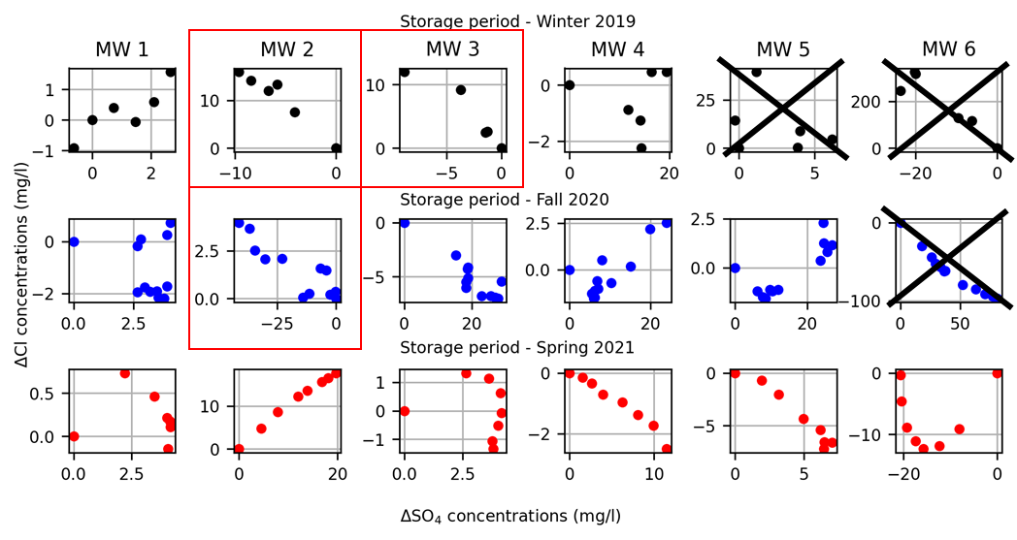

Figure S: Delta SO4 versus Delta Cl concentrations, where delta is the concentration versus the starting concentration. SO4-reducing conditions are indicated by decreasing delta SO4 concentrations, while Cl concentrations remain stable, increase, or decrease slower than SO4. These depths and storage periods are highlighted in red rectangles. The depths and storage periods where Cl deviations were >25% are displayed with a black cross.

## S2.5 Correlation between As and PO4 concentrations during storage periods

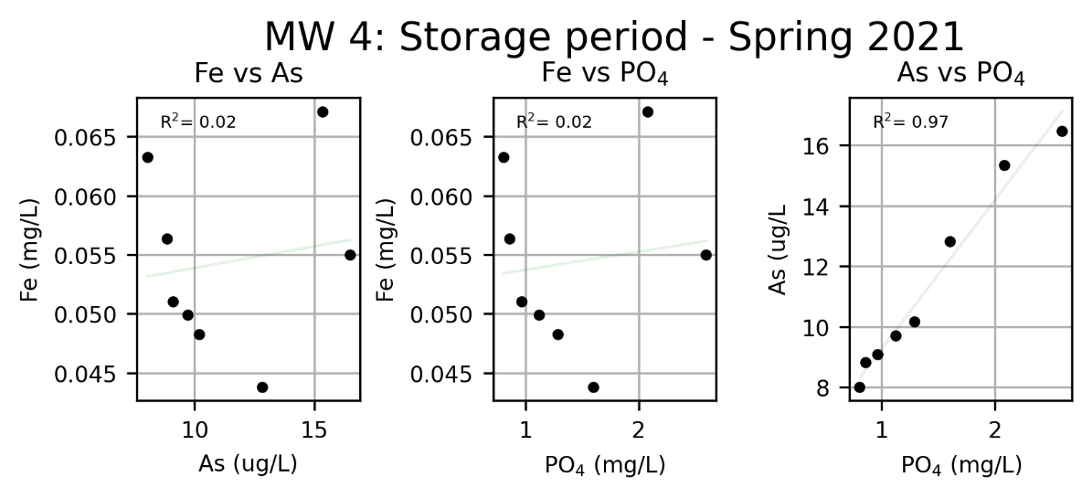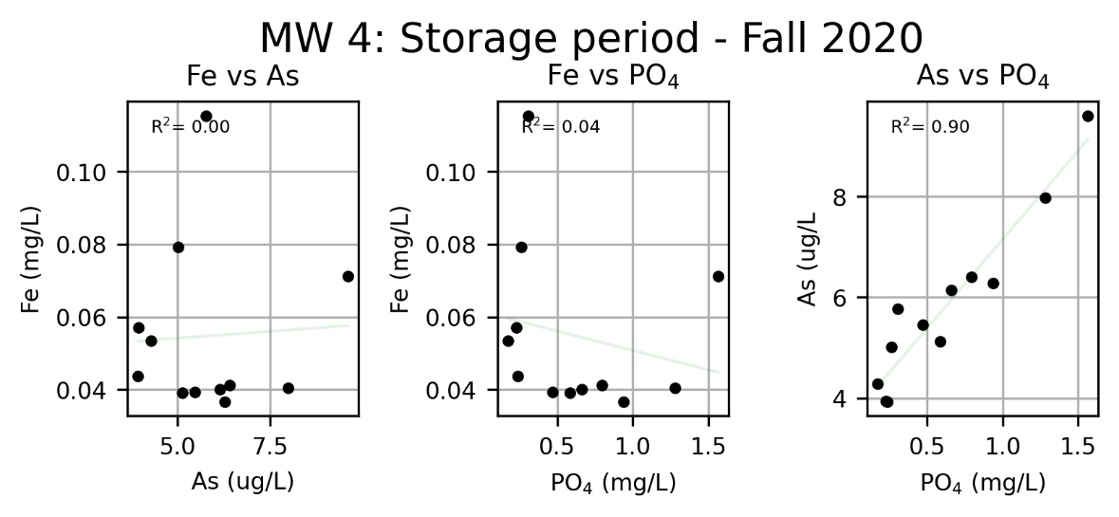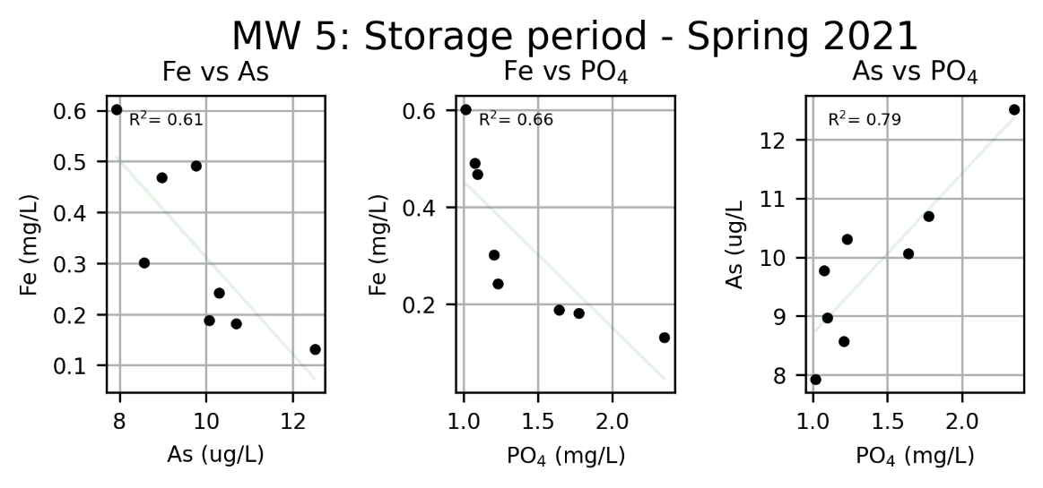

Figure S: Correlation between As and PO4 concentrations during storage periods in NO3-reducing conditions.

## S2.6 Saturation indices at the onset of storage periods

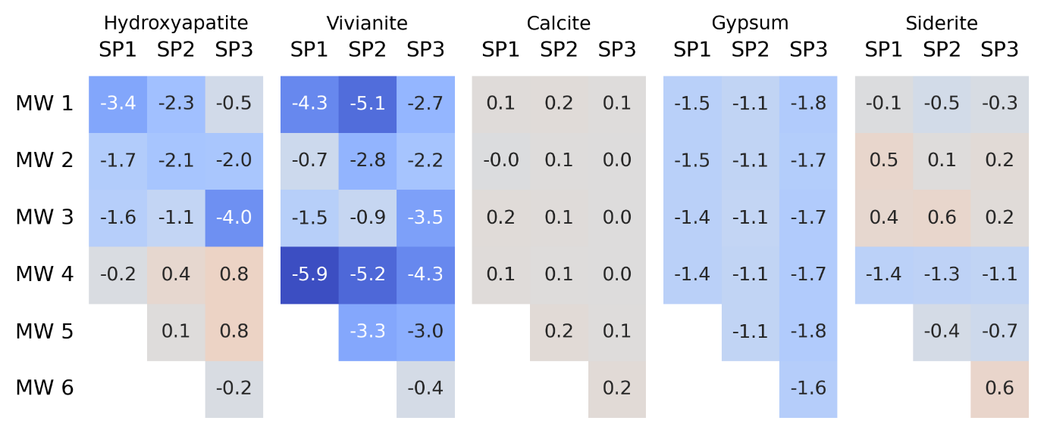

Figure S: Saturation indices obtained at the start of the different storage periods at the different well screen depths. SP1 is an abbreviation for the winter 2019 storage period, SP2 for the fall 2020 storage period, and SP3 for the spring 2021 storage period.

## S2.7 Saturation indices magnetite at the onset of storage periods

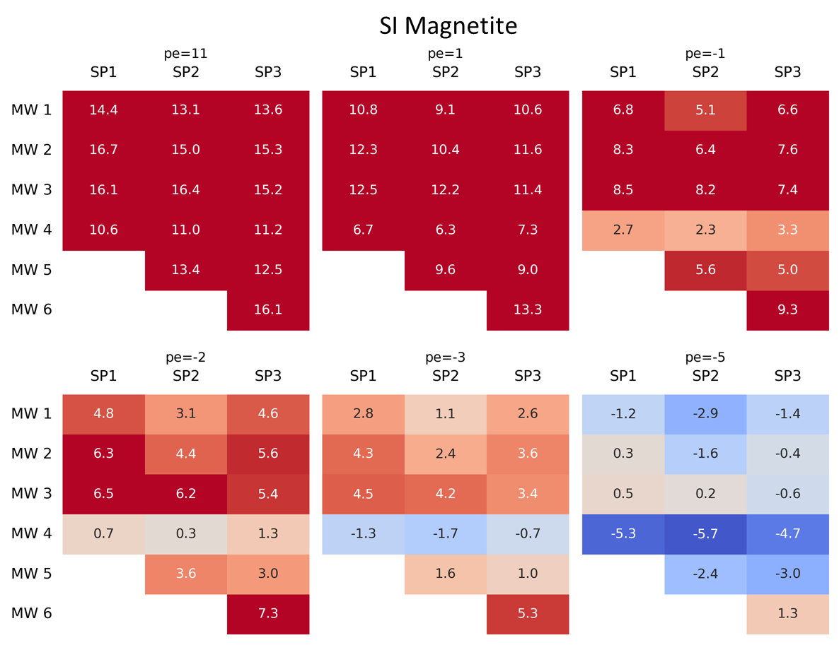

Figure S: Saturation indices of Magnetite at different pe. SP1 is an abbreviation for the winter 2019 storage period, SP2 for the fall 2020 storage period, and SP3 for the spring 2021 storage period.

# S3. Methanogenesis

We did a single CH4 analysis on watersamples taken from MW1-MW6 and from 6 monitoring wells at 15 m from injection well A (MW-B1 – B6; with well screens on the same depths as MW1-6) at 7 May 2021, approximately 2 months after last ASTR injection period, and 4 days after the spring 2021 storage period. On this day, no influences of the injected TDW were expected in MW-B1,B2,B5, and B6. Therefore, the data on these depths represents ambient groundwater. A decreasing trend was observed with depth on these samples, with 40.1 mg/L CH4 at MW-1 decreasing till 11.5 mg/L in MW6. In MW1-MW6, CH4 concentrations were notably lower, with some slight variations at the different depths. The low concentrations show that methanogenesis is not or negligibly occurring at these depths.

Table S: Methane (CH4) concentrations at 2.5m and 15m from the injection well. The concentrations written in red letters are influenced by the injected TDW.

|  |  |  |
| --- | --- | --- |
| CH4 (mg/L) | MW-2.5m | MW-15m |
| MW1 | 0.12 | 40 |
| MW2 | 0.57 | 39 |
| MW3 | 0.18 | 15 |
| MW4 | 0.05 | 0.48 |
| MW5 | 0.06 | 29 |
| MW6 | 0.11 | 11 |

# References

Bear, J., 2012. Hydraulics of groundwater. Courier Corporation.

Domenico, P.A., Schwartz, F.W., 1998. Physical and chemical hydrogeology. Wiley New York.